Question 1
- 1 – phenylalanine, 2 – arginine, 3 – isoleucine, 4 – glutamic acid, 5 – asparagine, 6 – aspartic acid
- N-terminus: blue, C-terminus: red
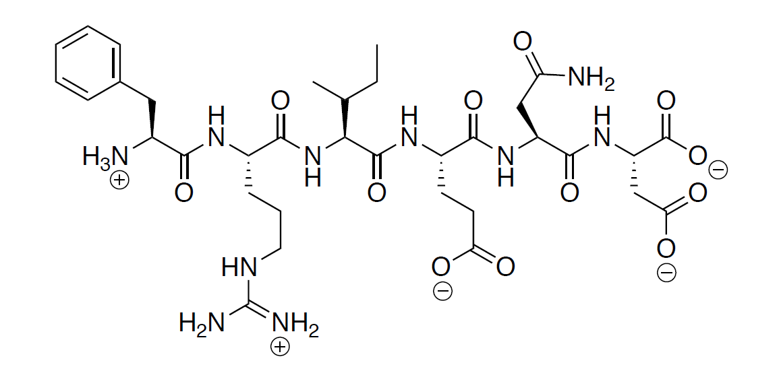

- Primary:
Secondary:
Tertiary:
Quaternary:

Question 2
- C, A, G

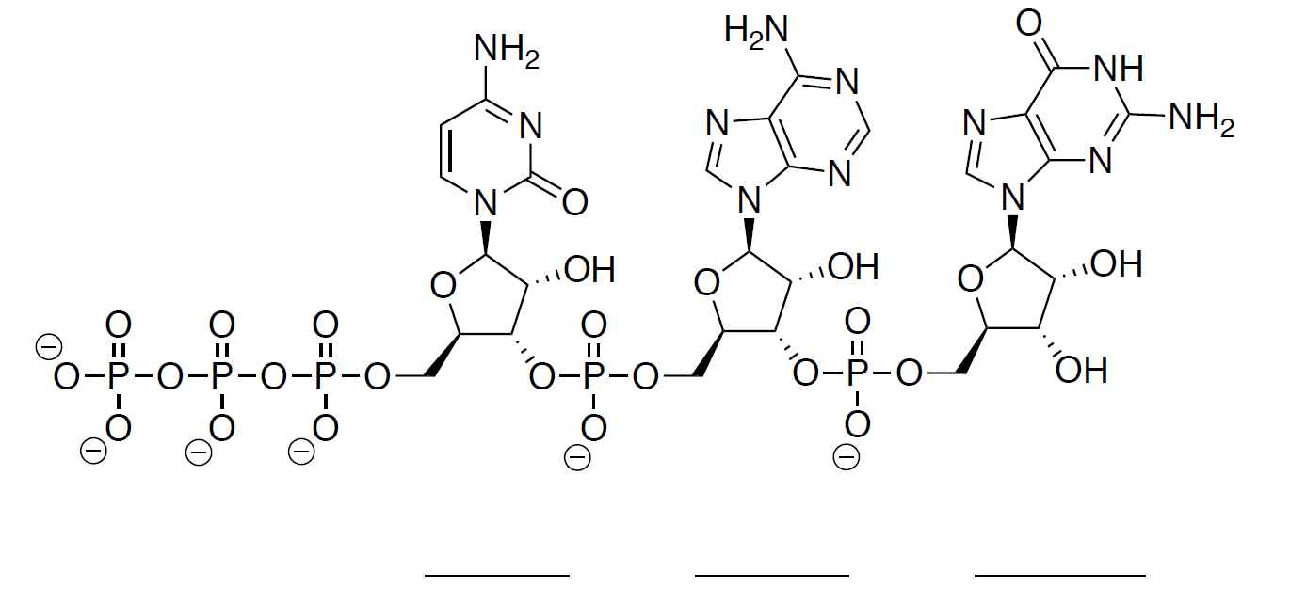
3’
5’
G
A
C
- RNA, as the sugar in the molecule is a ribose instead of deoxyribose. It has a hydroxyl group at carbon number 2 of the sugar.
- 5’ C T G 3’
- Hydrogen-bonding of the nucleobases

Question 3
- It’s in alpha-form as the acetal oxygen is pointing backward (hashed bonds). If it is drawn in chair conformation or Haworth’s projection, it would point down.
- C₁₁H₂₂O₁₁
- Disaccharide as it is formed from two simplest sugar (monosaccharide), joined by a glycoside bond.
- 9 Stereocenters.
- 2⁹ = 512 stereoisomers possible.

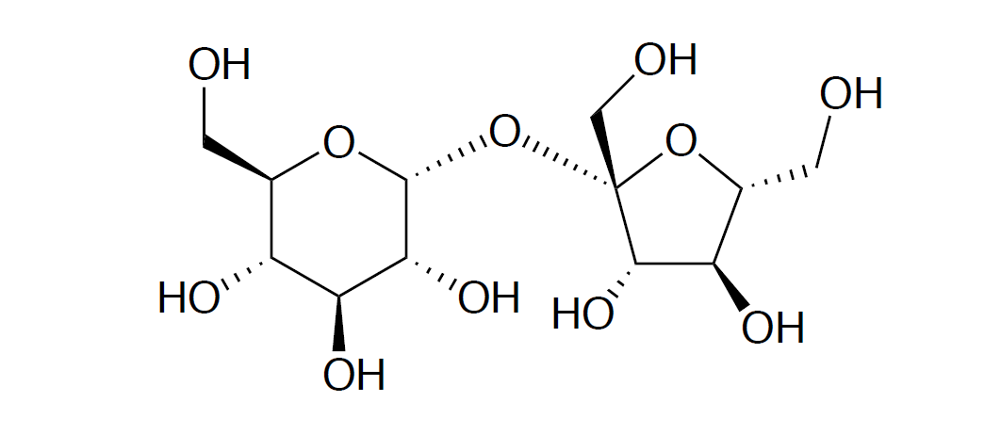

R
*
- The hydroxyl groups, as they are able to form hydrogen bonds with water.

Question 4
- Polyunsaturated fatty acid
- Unsaturated, as it contains double bonds in the structure
- Carboxylic acid (RCOOH) and alkene (C=C)
- All double bonds in the structure is cis-.
- C₂₆H₄₂O₂
- The additions of double bonds would bend a fatty acid molecule, resulting in a less surface area of the structure and less intermolecular forces, leading to a lowering in melting point.
- Hydrogenation of cis-fatty acids that leads to isomerization. Reagents: H₂, Pd/C

Question 5

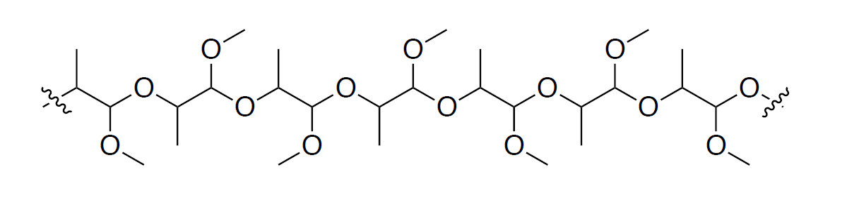
- Homopolymer as it only consists of a single monomeric unit.
- 2 Stereocenters
- Chain length: The longer the chain, the higher the tendency of a polymer to form crystalline structures.
Chain branch: The more unbranched the polymer, the higher the tendency of a polymer of form crystalline structures.
Interchain bonding: This helps the polymer to align itself to form crystalline structures
- Cationic polymerization (positive charge) and anionic polymerization (negative charge)

Question 6
